**Emergency**

**Medical**

**Technician**

**Class**

**The Karuk Tribe and Happy Camp Volunteer Ambulance present**

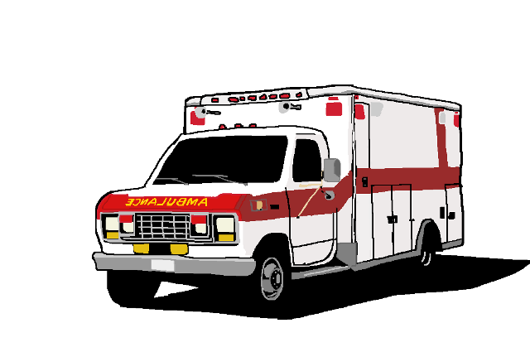

**Tuesday and Friday evenings @ 5:30**



**Starting - November 8, 2016**

Course Coordinator: Laurel Pena, EMT-P and Kirk Eadie, EMT II – EMS Manager Happy Camp Vol. Ambulance

Instructors: Dave Welin, EMT-P and Assistant: Kirk Eadie

**Fees:** $200 per student course materials not included

(Additional info: [happycampambulance.com](http://www.happycampambulance.com/))

Class Location: Happy Camp Elementary School

130 Park Way, Happy Camp, CA

**To Register:** Call 530-493-2643 Ambulance office (leave message if we are out on call) or send us an email at [hcvamb22@yahoo.com](mailto:hcvamb22@yahoo.com)

Feel free to stop by the ambulance office at – 38 Park Way, Happy Camp